**VISVESVARAYA TECHNOLOGICAL UNIVERSITY**



MINI PROJECT REPORT ON

**“IOT BASED SMART HELEMT”**

SUBMITTED BY:

**DEEPIKA T ( 1NH18EC710)**

**ISABELLA PAUL ( 1NH18EC717)**

**KAVYA S ( 1NH18EC724)**

**LINGESH T (1NH18EC727)**

Under the guidance of

**Mr. Mamtha B. Savadatti**

Assistant Professor, Dept. of ECE, NHCE, Bengaluru.



**NEW HORIZON COLLEGE OF ENGINEERING**

**(ISO-9001:2000 certified, Accredited by NAAC ‘A’,**

**Autonomous college permanently affiliated to VTU)Outer**

**Ring Road, Panathur Post, Near Marathalli, Bengaluru-**

**560103**

**NEW HORIZON COLLEGE OF ENGINEERING**

**DEPARTMENT OF ELECTRONICS AND COMMUNICATION ENGINEERING**



**CERTIFICATE**

Certified that the mini project work entitled “Detection of sleep apnea in infant” carried out by **Deepika T(1NH18EC710),Isabella paul(1NH18EC717),Kavya**

**S(1NH18EC724),Lingesh T(1NH18EC727)** bonafide students of Electronics and Communication Department , New Horizon College of Engineering, Bangalore.

The mini project report has been approved as it satisfies the academic requirements in respect of mini project work prescribed for the said degree.

Project Guide HOD ECE

------------------------- -------------------------

**External Viva**

Name of Examiner Signature with Date

1.

2.

**ACKNOWLEDGEMENT**

The satisfaction that accompany the successful completion of any task would be, but impossible without the mention of the people who made it possible, whose constant guidance and encouragement helped us succeed.

We thank **Dr. Mohan Manghnani**, Chairman of **New Horizon Educational Institution**, for providing necessary infrastructure and creating good environment.

We also record here the constant encouragement and facilities extended to us by **Dr.Manjunatha**, Principal, NHCE and **Dr. Sanjeev Sharma**, head of the department of Electronics and Communication Engineering. We extend sincere gratitude to them.

We sincerely acknowledge the encouragement, timely help and guidance to us by our beloved guide **Mamtha .B Savadatti** to complete the project within stipulated time successfully.

Finally, a note of thanks to the teaching and non-teaching staff of electronics and communication department for their co-operation extended to us, who helped us directly or indirectly in this successful completion of mini project.

**DEEPIKA T(1NH18EC710)**

**ISABELLA PAUL(1NH18EC717)**

**KAVYA S (1NH18EC724)**

**LINGESH T(1NH18EC727)**

**TABLE OF CONTENTS**

ABSTRACT

**CHAPTER 1**

INTRODUCTION………………………………………………………………………………8

**CHAPTER 2**

LITERATUREREVIEW………………………………………………………………………9

2.1 PROJECTS TO BE DISCUSSED………………………………………………………….9

**CHAPTER 3**

EXISTING SYSTEM AND PROBLEM STATEMENT………………………………………10

3.1 PROBLEMSTATEMENT…………………………………………………………………10

3.2 EXISTING SYSTEM ……………….……………………………………………………...10

**CHAPTER 4**

PROPOSED SYSTEMS ………………………………………………………………………..11

4.1 CIRCUIT DIAGRAM………………………………………………………………………11

4.2 BLOCK DIAGRAM………………………………………………………………………..12

4.3 WORKING…………………………………………………………………………………..13

**CHAPTER 5**

HARDWARE AND SOFTWARE SPECIFICATION…………………………………………14

5.1 HARDWARE SPECIFICATION…...……………………………………………………….14

5.1.1 MICROCONTROLLER………….…..……………………………………………………14

5.1.2 RESISTOR…………………………...…………………………………………………….16

5.1.3 BREADBOARD…………………………………………………………………………..16

5.1.4 WIFI MODULE……………………….…………………………………………………..17

5.1.5 RF MODULE……………………………………………………………………………18

5.1.6 CAPACITORS….………………………………………………………………………..21

5.1.7 CRYSTAL OSCILLATOR……………………………………………………………….22

5.1.8 LCD………………………………………………………………………………………23

5.1.9 DIODE ………………………………………………………………………………….25

5.1.10 PCB……………………………………………………………………………………...26

5.1.11 IC…………………………………………………………………………………………27

5.1.12 TRANSISTOR……………………………………………………………………………28

1. 1.13TRANFORMER…………………………………………………………………………29

5.1.14 BUZZER………………………………………………………………………………..30

5.1.15 CABLES AND CONNECTOR…………………………………………………………31

5.1.16 PUSH BUTTON………………………………………………………………………..32

* 1. SOFTWARE SPECIFICATION……………………………………………………………32
     1. C LANGUAGE……………………………………………………………………………32
     2. IOT GECKO………………………………………………………………………………33

**CHAPTER 6**

RESULT AND DISCUSSION…………..………………………………………………………34

**CHAPTER 7**

CONCLUSION AND FUTURE SCOPE……………………………………………………….35

**CHAPTER 8**

APPLICATIONS AND ADVANTAGES……………………………………………………….37

7.1 APPLICATIONS…………………………………………………………………………….37 7.2 ADVANTAGES……………………………………………………………………………..37

REFERENCES………………………………………………………………………………….38

APPENDIX……………………………………………………………………………………..39

**LIST OF FIGURES**

|  |  |  |  |
| --- | --- | --- | --- |
| **SL**  **No** | **FIGURE**  **No** | **FIGURE DESCRIPTION** | **Page**  **No** |
| 1 | 4.1 | CIRCUIT DIAGRAM | 11 |
| 2 | 4.2 | BLOCK DIAGRAM | 12 |
| 3 | 4.3. | FLOW CHART | 12 |
| 4 | 5.1 | MICROCONTROLLER CHIP | 15 |
| 5 | 5.2 | MICROCONTROLLER PIN DIAGRAM | 15 |
| 6 | 5.3 | RESISTOR | 16 |
| 7 | 5.4 | BREAD BOARD | 16 |
| 8 | 5.5 | WIFI MODULE | 17 |
| 9 | 5.6 | RF MODULE | 18 |
| 10 | 5.7 | RF TRANSMITTER(ENCODER) | 19 |
| 11 | 5.8 | RF RECEIVER(DECODER) | 20 |
| 12 | 5.9 | CAPACITOR | 21 |
| 13 | 5.10 | CRYSTAL OSCILLATOR | 22 |
| 14 | 5.11 | LCD | 23 |
| 15 | 5.12 | LCD PIN DIAGRAM | 23 |
| 16 | 5.13 | DIODE | 24 |
| 17 | 5.14 | PCB | 25 |
| 18 | 5.15 | IC | 26 |
| 19 | 5.16 | TRANSISTOR | 27 |
| 20 | 5.17 | TRANSFORMER CIRCUIT | 28 |
| 21 | 5.18 | TRANSFORMER | 28 |
| 22 | 5.19 | BUZZER | 29 |
| 23 | 5.20 | CABLE | 30 |
| 24 | 5.21 | PUSH BUTTON | 31 |

**ABSTRACT**

The current situation on the security of diggers is a critical test for the world's mine working associations, because of loads of shrouded risks. Digger's working condition is risky, and life is in danger in light of a few basic issues that join the working environment just as its possible result. A wellbeing checking and cautioning framework are fundamental inside the mining territory to evade any kinds of undesirable wonders and to increment both security and efficiency in mines. This work proposed a multi-sensor-based checking framework for balanced consideration of risky and poisonous gases, for example, CO, SO2, NO2 and different imperatives present in hid mine.

**CHAPTER 01**

**INTRODUCTION**

Mining is one of the most risky exchanges everywhere on the world. In certain nations, underground diggers need security, social assurances and if there should be an occurrence of injury might be left to adapt without help. Regular causes of word related passing’s incorporate stone falls, fires, blasts, methane inebriation, and electric shock.

These dangers are expected if there should be an occurrence of coal enterprises. In this way, security of laborers ought to consistently be of significant thought in any type of Underground mining tasks ends up being a hazardous endeavor similarly as the security and wellbeing of laborers are concerned. These dangers are because of various strategies utilized for separating various minerals. The more profound the mine, the more noteworthy is the danger. These wellbeing issues are of grave concern particularly in the event of coal enterprises. Subsequently, wellbeing of laborers ought to consistently be of significant thought in any type of mining, regardless of whether it is coal or some other minerals.

Underground coal mining includes a higher danger than open pit mining because of the issues of ventilation and potential for breakdown. In any case, the use of substantial apparatus and the strategies performed during unearthing’s result into dangers in a wide range of mining Underground coal mining includes a higher danger than open pit mining because of the issues of ventilation and potential for breakdown. In any case, the use of substantial apparatus and the strategies performed during unearthing’s result into dangers in a wide range of mining

**CHAPTER 02**

**LITERATURE REVIEW**

**2.1 Projects to be discussed**

Yongping Wu and Guo Feng proposed a coal mine checking utilizing the Bluetooth remote transmission framework. As a norm of brought together global short-range remote communication, Bluetooth innovation is to build up a basic low-power, ease remote opening framework. The framework uses CAN transport innovation maturely, has understood the combination of wired and remote information transmission framework The principle trouble of this framework is that the Bluetooth is short distance remote innovation and utilization of cabling is troublesome.

Jingiiang Song, Yingli Zhu implemented automatic checking framework for coal mine wellbeing with wireless sensor network. The sensor gatherings of the framework temperature,humidity and different parameters in the underground mine, parameters estimated are shipped off wireless communication module by the micro-controller.

Pranjal Hzarika proposed usage of the safety helmet for a coal excavation employees. This helmet is outfitted with methane series and carbon monoxide gas sensors. This device sense the gas and also the information is distributed to the room wirelessly, through a wireless module referred to as Zigbee related to the helmet

**CHAPTER 03**

**EXISTING SYSTEM AND PROBLEM STATEMENT**

**3.1EXISTING SYTSTEM**

The problem self-addressed during this project was the development of a mining helmet so as to make sure a lot of safety awareness between miners. once operating with abuzz instrumentality, being conscious of one’s surroundings will sometimes be difficult. within the mining trade miners tend to induce eliminate a number of their safety gear as aresult of the gear is simply too vital, heat or uncomfortable to figure with. Thus this method is developed to intimate the authorities in crucial conditions

**3.2PROBLEM STATEMENT**

The current situation on the security of diggers is a critical test for the world's mine working associations, because of loads of shrouded risks. Digger's working condition is risky, and life is in danger in light of a few basic issues that join the working environment just as its possible result. A wellbeing checking and cautioning framework are fundamental inside the mining territory to evade any kinds of undesirable wonders and to increment both security and efficiency in mines. This work proposed a multi-sensor-based checking framework for balanced consideration of risky and poisonous gases, for example, CO, SO2, NO2 and different imperatives present in hid mine.

**CHAPTER 04**

**PROPOSED SYSTEMS**

**4.1CIRCUIT DIAGRAM**

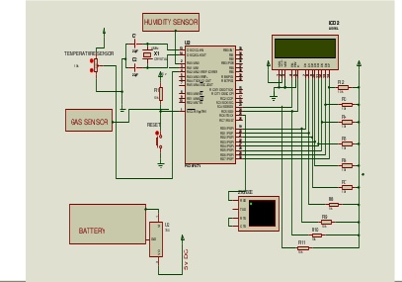

**Fig 4.1 : Circuit diagram**

**4.2BLOCK DIAGRAM**

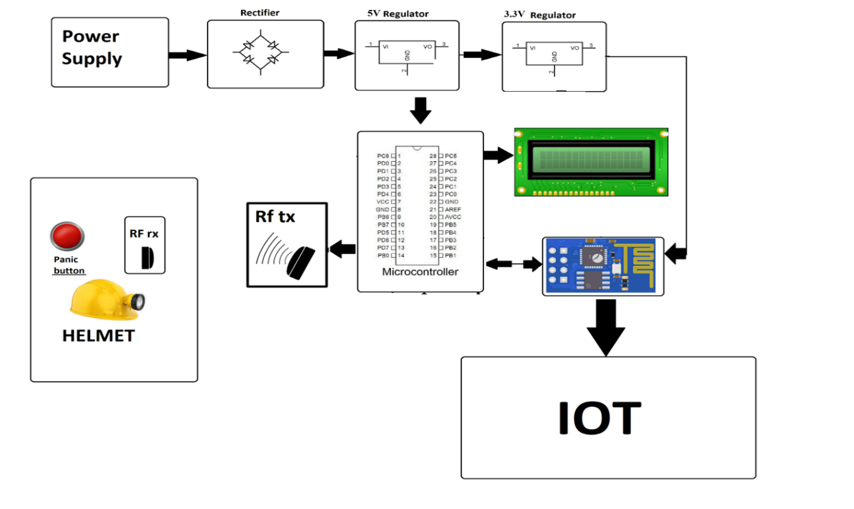

**Fig 4.2: Block diagram of helmet**

**4.3WORKING**

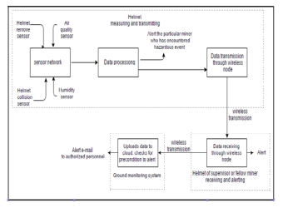

**Fig 4.3: Flow chart of working**

This is a sensor network which will consist of air quality sensor, humidity sensor, temperature sensor .

Air pollution sensors -are devices that monitor the presence of air pollution in the surrounding area.

Humidity sensors- detect the relative humidity of the immediate environments in which they are placed.

Temperature sensor- is an electronic device that measures the temperature of its environment and converts the input data into electronic data to record, monitor, or signal temperature changes.

The sensor network will send all the gathered information and send it to data processing, where analysis takes place. The top part is the helmet and the bottom part is the cloud. From there the data is processed ,it is transferred through wireless mode .The wireless transmission will reach the main processor, where it receives the data through the wireless node and we will get an alert, if the value exceeds the minimum value which we have fed in the processor. The alert is sent as an e-mail, the mail will have the details of the miner and also the fault that has occurred.

**CHAPTER 5**

**5.1HARDWARE AND SOFTWARE SPECIFICATION**

**5.1.1MICROCONTROLLER ( PIC18F4520)**

In 2000, Microchip presented the PIC18 architecture. Unlike the 17 arrangement, it has demonstrated to be well known, with countless gadget variations as of now in production. As opposed to before gadgets, which were as a rule customized in gathering, C has become the overwhelming advancement language.

The 18 arrangement acquires a large portion of the highlights and directions of the 17 arrangement, while adding various significant new highlights: call stack is 21 pieces wide and a lot further (31 levels profound)

The call stack might be perused and composed (TOSU:TOSH:TOSL registers) contingent branch directions recorded tending to mode (PLUSW)stretching out the FSR registers to 12 pieces, permitting them to straightly address the whole information address space the expansion of another FSR register (bringing the number up to 3) .The RAM space is 12 pieces, tended to utilizing a 4-cycle bank select register and a 8-bit balance in every guidance. An extra "access" bit in every guidance chooses between bank 0 (a=0) and the bank chose by the BSR (a=1).

A 1-level stack is likewise accessible for the STATUS, WREG and BSR registers. They are saved money on each intrude, and might be reestablished on return. In the event that hinders are impaired, they may likewise be utilized on subroutine call/return by setting the s digit (annexing ", FAST" to the guidance).

The auto addition/decrement highlight was improved by eliminating the control bits and adding four new roundabout registers for every FSR. Contingent upon which backhanded record register is being gotten to it is conceivable to postdecrement, postincrement, or preincrement FSR; or structure the viable location by adding W to FSR.

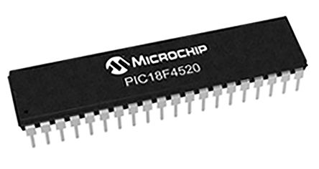In further developed PIC18 gadgets, an "expanded mode" is accessible which makes the tending to significantly more good for arranged code: another counterbalance tending to mode; a few delivers which were comparative with the entrance bank are presently deciphered comparative with the FSR2 register the expansion of a few new directions, striking for controlling the FSR registers. PIC18 gadgets are as yet evolved (2017) and fitted with CIP (Core Independent Peripherals)

**Fig 5.1: Microprocessor chip**

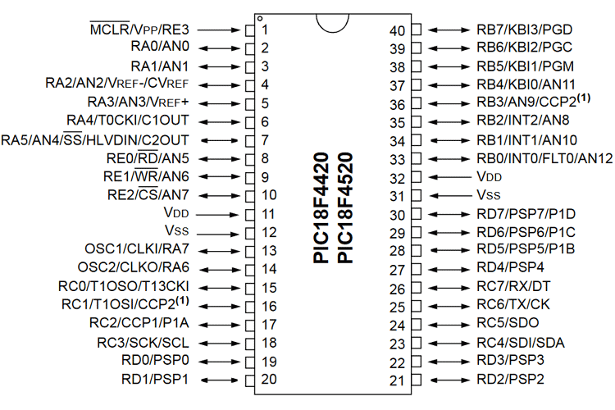

**Fig 5.2: Microprocessor pin diagram**

**5.1.2RESISTOR**

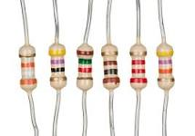

**Fig 5.3: Resistor**

Resistors are electronic parts which have a particular, failing to change electrical opposition. The resistor's opposition restricts the progression of electrons through a circuit. They are aloof segments, which means they just consume power (and can't create it). Resistors are generally added to circuits where they supplement dynamic segments like operation amps, microcontrollers, and other incorporated circuits. Ordinarily resistors are utilized to constrain current, partition voltages, and draw up I/O lines.

**5.1.3BREAD BOARD**

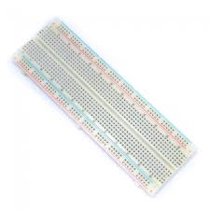

**Fig 5.4: Bread board**

A breadboard is a rectangular board with many mounting gaps. They are utilized for making electrical associations between electronic parts. The associations aren't perpetual and they can be evacuated and set once more. Indeed, you can even supplant segments to redo your venture or work on a totally extraordinary one, utilizing a similar breadboard. The vertical segments of the breadboard are called terminals, while the flat long columns are called power rails since they are for the most part used to associate the power supply to the breadboard. The positive rails are shown by red lines, while the negative rails are demonstrated by dark ones.

**5.1.4WIFI MODULE**

ESP8266 is Wi-Fi empowered framework on chip (SoC) module created by Espressif framework. It is generally utilized for advancement of IoT (Internet of Things) installed applications.

ESP8266 accompanies abilities of

* 2.4 GHz Wi-Fi (802.11 b/g/n, supporting WPA/WPA2)
* universally useful information/yield (16 GPIO)
* Inter-Integrated Circuit (I²C) serial communication protocol
* analog-to-digital change (10-bit ADC)
* Serial Peripheral Interface (SPI) serial communication protocol
* I²S (Inter-IC Sound) interfaces with DMA(Direct Memory Access) (imparting pins to GPIO)
* UART (on devoted pins, in addition to a send just UART can be empowered on GPIO2)
* Pulse- width modulation (PWM).

It utilizes a 32-digit RISC CPU dependent on the Tensilica Xtensa L106 running at 80 MHz (or overclocked to 160 MHz). It has a 64 KB boot ROM, 64 KB guidance RAM and 96 KB information RAM. Outside flash memory can be gotten to through SPI.

Top of Form

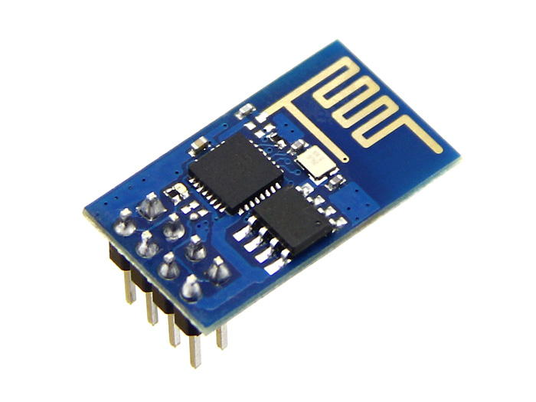

**Fig 5.5: Wifi module**

**5.1.5RF MODULE**

As the name proposes, RF module works at Radio Frequency. This recurrence range differs between 30 kHz and 300 GHz. In this RF framework, the computerized information is spoken to as varieties in the adequacy of transporter wave. This sorts of tweak is an Amplitude Shift Keying (ASK) . This RF module is a mix of RF Transmitter and RF Receiver. The transmitter/receiver (Tx/Rx) pair works at a recurrence of 433 MHz.

The RF transmitter gets sequential information and sends it remotely through its RF reception apparatus. The transmission happens at the pace of 1 Kbps – 10 Kbps. RF receiver gets the sent information and it is working at a similar recurrence as that of the transmitter.

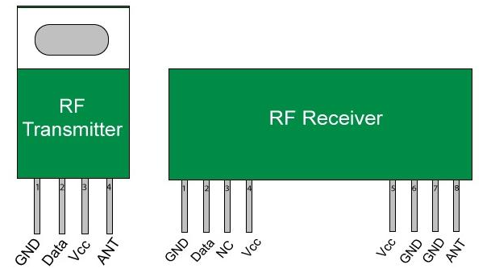

**Fig 5.6: RF module**

In numerous ventures, we use RF modules to sending and getting the information since it has a high volume of uses than IR. RF handset module will consistently work in a couple that is it needs a Transmitter and Receiver to send and get the information. A transmitter can just send data and a Receiver and can just get it, so information can send starting with one end then onto the next and not the opposite way around.

The Transmitter module comprises of three pins in particular Vcc, Din and ground as appeared previously. The Vcc pin has a wide reach input voltage from 3V to 12V. The transmitter burns-through a base current of 9mA and can go as high as 40mA during transmission. The middle pin is the information pin to transmit the sign. This sign adjusted utilizing the ASK and afterward sent on air at a recurrence of 433MHz.

RF receiver module has four pins to be specific Vcc, Dout, Linear out and Ground as appeared previously. The Vcc pin should be fueled with a managed 5V stock. The working current of this module is under 5.5mA. The pins Dout and Linear out is shorted together to get the 433Mhz sign from air. This sign is then demodulated to get the information and conveyed through the information pin.

HT12E is an encoder IC that changes over the 4-digit equal information from the 4 information pins into sequential information to communicate over RF 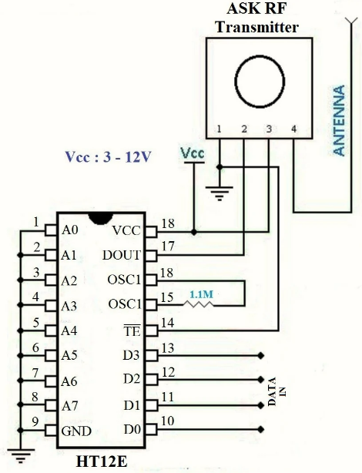

**Fig 5.7 : RF transmitter (Encoder)**

Connect utilizing transmitter.

HT12D is a decoder IC that changes over the sequential information got by the RF Receiver into 4-cycle equal information and drives the yield in like manner. 

**Fig 5.8: RF receiver( decoder)**

**5.1.6 CAPACITORS**

The capacitor is a part which has the capacity or "limit" to store energy as an electrical charge delivering a possible distinction (Static Voltage) across its plates, much like a little battery-powered battery.

There are a wide range of sorts of capacitors accessible from tiny capacitor globules utilized in reverberation circuits to enormous force factor remedy capacitors, however they all do something very similar, they store charge.

In its essential structure, a capacitor comprises of at least two equal conductive (metal) plates which are not associated or contacting one another, yet are electrically isolated either via air or by some type of a decent protecting material, for example, waxed paper, mica, clay, plastic or some type of a liquid gel as utilized in electrolytic capacitors. The protecting layer between a capacitors plates is generally called the Dielectric.

Because of this protecting layer, DC flow cannot course through the capacitor as it blocks it permitting rather a voltage to be available across the plates as an electrical charge.

The conductive metal plates of a capacitor can be either square, round or rectangular, or they can be of a tube shaped or circular shape with the overall shape, size and development of an equal plate capacitor relying upon its application and voltage rating.

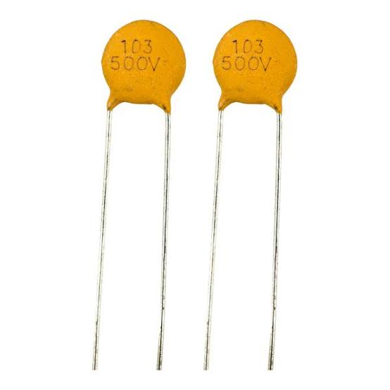

**Fig 5.9: Capacitor**

**5.1.7CRYSTAL OSCILLATOR**

Quite possibly the main features of any oscillator is its frequency strength, or at the end of the day its capacity to give a consistent frequency output under shifting burden conditions.

A portion of the components that influence the frequency security of an oscillator for the most part include: varieties in temperature, varieties in the heap, just as changes to its DC power supply voltage to give some examples.

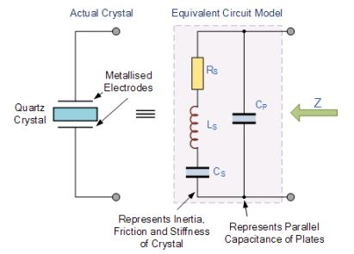

**Fig 5.10: Crystal oscillator**

Frequency solidness of the output signal can be incredibly improved by the appropriate determination of the parts utilized for the resounding feedback circuit, including the speaker. In any case, there is a breaking point to the strength that can be gotten from typical LC and RC tank circuits.

To acquire an extremely significant level of oscillator security a Quartz Crystal is by and large utilized as the frequency deciding gadget to deliver another kinds of oscillator circuit referred to for the most part as a Quartz Crystal Oscillator.

**5.1.8LCD**

LCD (Liquid Crystal Display) is a sort of level board display which utilizes liquid crystals in its essential type of activity. LEDs have a huge and differing set of utilization cases for buyers and organizations, as they can be regularly found in cell phones, TVs, PC screens and instrument boards.

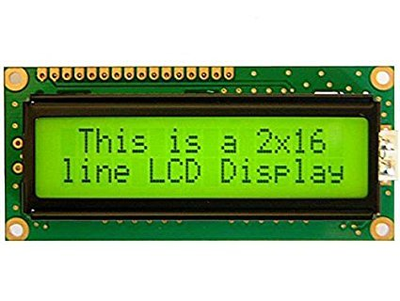

**Fig 5.11: LCD**

LCDs were a major jump regarding the innovation they supplanted, which incorporate light-discharging diode (LED) and gas-plasma displays. LCDs permitted displays to be a lot more slender than cathode ray tube (CRT) innovation. LCDs burn-through considerably less force than LED and gas-display displays since they work on the guideline of obstructing light as opposed to producing it. Where a LED discharges light, the liquid crystals in a LCD creates a picture utilizing a backdrop illumination. 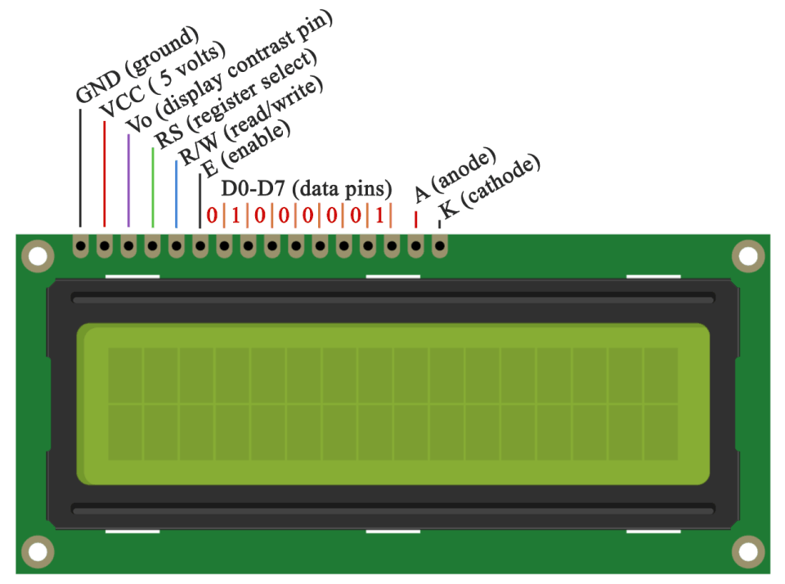

**Fig 5.12: LCD Pin diagram**

As LCDs have supplanted more seasoned display innovations, LCDs have started being supplanted by new display advancements, for example, OLEDs.

**5.1.9DIODE**

A diode is characterized as a two-terminal electronic phase that solitary behaviors current in one direction (inasmuch because it is worked within a predefined voltage level). A perfect diode can have zero obstruction in one direction, and infinite opposition within the reverse direction.

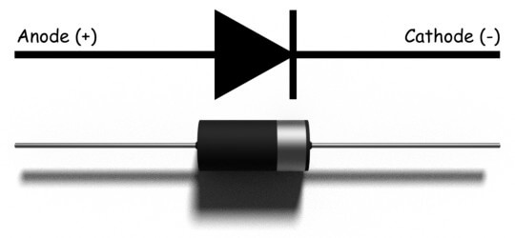

**Fig 5.13: Diode**

Albeit truly, diodes cannot accomplish zero or infinite opposition. All things thought-about, a diode can have irrelevant obstruction in one direction (to allow current stream), and high opposition within the reverse direction (to forestall current stream). A diode is with success just like a valve for Associate in nursing electrical device.

Semiconductor diodes are the foremost widely known type of diode. These diodes begin leading power simply if a particular edge voltage is accessible within the forward direction (for example the "low opposition" direction). The diode is meant to be "forward one-sided" once leading current during this direction. At the purpose once associated within a circuit within the reverse direction (for example the "high opposition" direction), the diode is meant to be "reverse one-sided".

**5.1.10 PCB**

Printed circuit board is that the most well-known name but could likewise be classified "printed wiring boards" or "printed wiring cards". Before the approaching of the PCB circuits were designed through a relentless cycle of point-to-point wiring. This prompted incessant disappointments at wire intersections and short-circuits once wire protection began to age and break.

PCB's have mechanical and electrical credits that create them ideal for these applications. Most PCB's created within the World are rigid, typically ninetieth of the PCB's made-up nowadays are rigid boards. Some PCB's are versatile, allowing the circuits to be bowed and folded into form, or range of} the time they're used wherever the versatile circuit can endure an enormous number of flex cycles, with no break within the circuits.

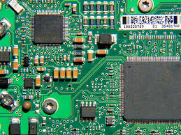

**Fig 5.14: PCB ( Printed circuit board)**

These versatile PCB's involve typically 100 percent of the market. A tiny low set of those types of circuits are known as rigid flex circuits, wherever one piece of the board is rigid – ideal for mounting and associating segments, and a minimum of one sections are versatile, giving the benefits of versatile circuits recorded antecedently.

**5.1.11 IC**

Integrated circuit (IC), likewise called microelectronic circuit, CPU, or chip, a get together of electronic segments, created as a solitary unit, in which scaled down dynamic gadgets (e.g., semiconductors and diodes) and uninvolved gadgets (e.g., capacitors and resistors) and their interconnections are developed on a flimsy substrate of semiconductor material (ordinarily silicon). The subsequent circuit is in this manner a little solid "chip," 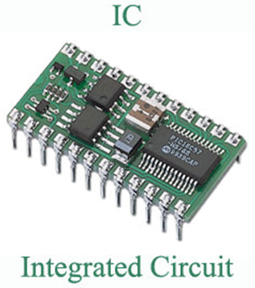

**Fig 5.15: IC (Integrated circuit)**

Which might be as little as a couple of square centimeters or a couple of square millimeters. The individual circuit parts are by and large minute in size.

ICs have two fundamental focal points over discrete circuits: cost and execution. Cost is low in light of the fact that the chips, with every one of their parts, are printed as a unit by photolithography instead of being built each semiconductor in turn. Moreover, bundled ICs utilize significantly less material than discrete circuits. Execution is high in light of the fact that the IC's parts switch rapidly and burn-through relatively little force due to their little size and vicinity. The fundamental weakness of ICs is the significant expense to plan them and manufacture the required photo masks. This high starting cost implies ICs are just financially practical when high creation volumes are envisioned.

**5.1.12TRANSISTOR**

The transistor is a semiconductor gadget which moves a frail signal from low resistance circuit to high resistance circuit. The words trans mean exchange property and istor mean resistance property offered to the intersections.

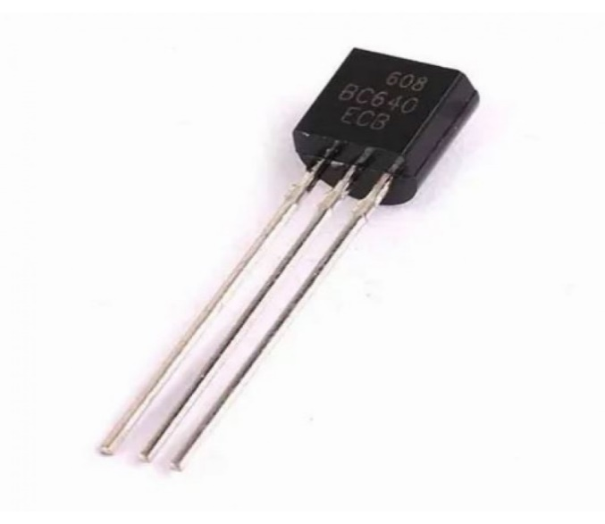

**Fig 5.16: Transistors**

At the end of the day, it is an exchanging gadget which manages and enhance the electrical signal preferences voltage or flow. The transistor comprises two PN diode associated consecutive. It has three terminals to be specific emitter, base and collector. The base is the middle segment which is comprised of flimsy layers. The correct piece of the diode is called emitter diode and the left part is called collector-base diode. These names are given according to the normal terminal of the transistor. The emitter based intersection of the transistor is associated with forward biased and the collector-base intersection is associated backward bias which offers a high resistance.

**5.1.13 TRANSFORMER**

A Transformer is a static electrical machine which moves AC electrical force from one circuit to the next circuit at the steady recurrence, however the voltage level can be adjusted that implies voltage can be expanded or diminished by the prerequisite.

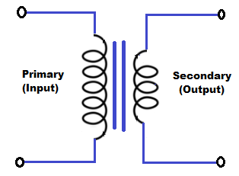

**Fig 5.17: Transformer circuit**

It deals with the rule of Faraday's Law of Electromagnetic Induction which expresses that " the extent of voltage is straightforwardly corresponding to the pace of progress of transition."

Normally, electrical force is produced at 11Kv. For affordable reasons AC power is communicated at exceptionally high voltages state 220 kV or 440 kV over significant distances. 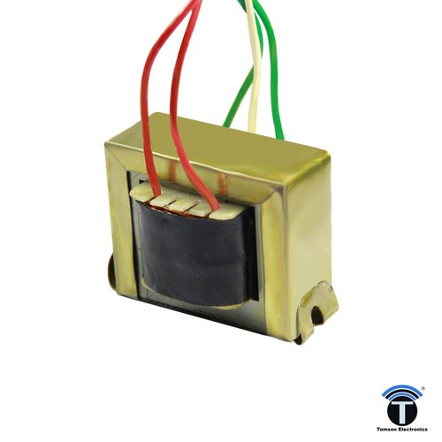

**Fig 5.18: Transformer**

In this way a stage up transformer is applied at the producing stations.

Presently for security reasons the voltage is ventured down to various levels by venture down transformer at different substations to take care of the ability to the various areas and hence the usage of intensity is done at 400/230 V. On the off chance that (V2 > V1) the voltage is raised on the yield side and is known as Step-up transformer

In the event that (V2 < V1) the voltage level is brought down on the yield side and is known as Step down transformer.

**5.1.14BUZZER**

A buzzer is a little yet efficient segment to add sound highlights to our undertaking/framework. It is little and compact 2-pin structure consequently can be handily utilized on breadboard, Perf Board and even on PCBs which makes this a broadly utilized segment in most electronic applications. There are two sorts are buzzers that are normally accessible. The one appeared here is a straightforward buzzer which when controlled will make a Continuous Beeeeeeppp.... sound, the other sort is known as a readymade buzzer which will look bulkier than this and will deliver a Beep. Signal. Signal. Sound because of the inner wavering circuit present inside it. In any case, the one appeared here is most broadly utilized on the grounds that it tends to be tweaked with assistance of different circuits to fit effectively in our application.

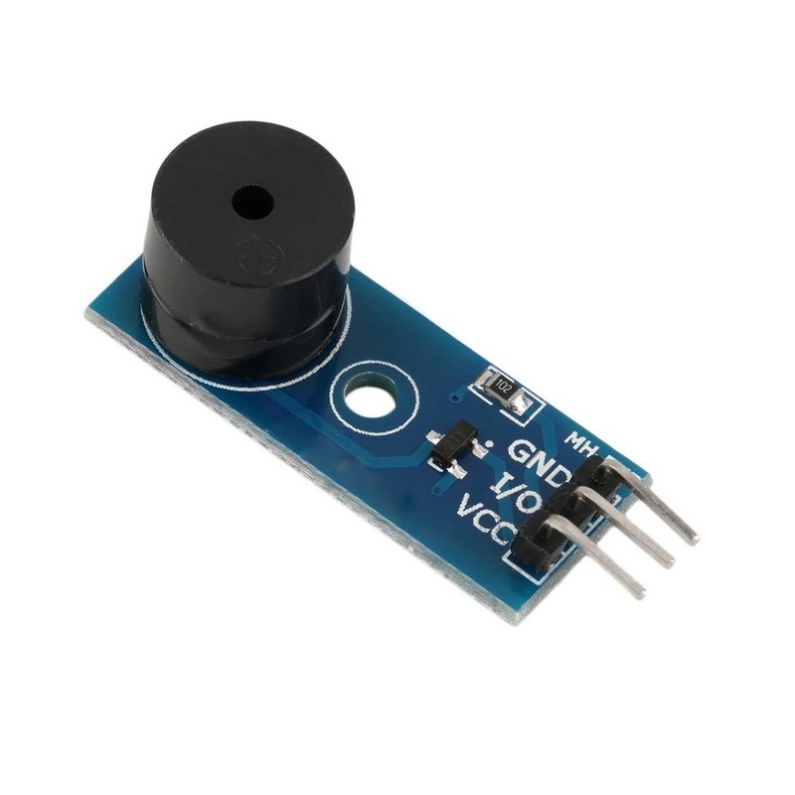

**Fig 5.19: Buzzer**

This buzzer can be utilized by basically powering it utilizing a DC power supply ranging from 4V to 9V. A straightforward 9V battery can likewise be utilized, yet it is prescribed to utilize a regulated +5V or +6V DC supply. The buzzer is typically connected with a changing circuit to kill ON or turn the buzzer at required time and require stretch.

Top of Form

**CABLES AND CONNECTORS**

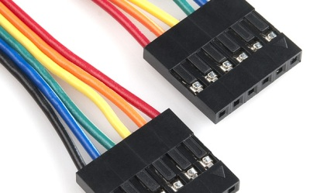

**Fig 5.20: Cable**

On the other hand referred to as a cord, connector or fitting, a cable is at least one wires shrouded in plastic that send force or information between gadgets or areas. ... There are two primary kinds of PC cables, an information cable and a force cable. An information cable is a cable that gives correspondence between gadgets.

**5.1.16 PUSH BUTTON**

A push button is a simple sort of switch that controls an activity in a machine or some kind of cycle. More often than not, the buttons are plastic or metal. The state of the push button may adjust to fingers or hands for simple use, or they may just be level. Everything relies upon the individual plan. The push button can be typically open or regularly shut.

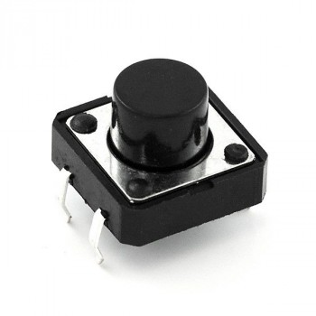

**Fig 5.21: Push button**

**5.2SOFTWARE SPECIFICATION**

**5.2.1C LANGUAGE**

C is a procedural programming language. It was at first evolved by Dennis Ritchie in the year 1972. It was basically evolved as a system programming language to compose a working system. The principle highlights of C language incorporate low-level admittance to memory, a basic arrangement of watchwords, and clean style, these highlights make C language reasonable for system programmings like a working system or compiler improvement.

**5.2.2IOT GECKO**

IOT Gecko is a free IOT systems improvement stage for understudies, specialists and designers. Opening ways to actual devices controlled over the internet, IOT Gecko gives you the tools and backing to design your IOT based systems effortlessly. Get sensor/device information and use it over the internet.

**CHAPTER 06**

RESULT AND DISCUSSION

We have assigned the default temperature at 35 and the default gases value at 400 and default B as 10 .If the values go above or below the assigned values, we will get an alert. If the value goes above the default values, a red light with high buzzer sound (loud) is the output. Now if the help doesn't arrive and don't take any action within 1000 seconds, there is a second alert with the same red alert, but with a lesser buzzer sound.

**CHAPTER 07**

**CONCLUSION AND FUTURE SCOPE**

A smart mining protective helmet was built up that can identify three kinds of risky occasions, for example, peril level of unsafe gases, digger protective cap eliminating, and crash or sway (diggers are struck by an article). The unsafe occasions were named an excavator eliminating the mining cap off their head. An off-the-rack IR sensor was then used to effectively decide when the protective cap is on the digger's head. Another unsafe occasion is characterized as an occasion whereminers are struck by an article against the head with a power surpassing an estimation of 1000 on the HIC (Head Injury Criteria).

An accelerometer was utilized to quantify the speeding up of the head and the HIC was determined in programming. The design of the perception programming was finished. Tests were effectively done to align the accelerometer. PCB's that were planned and made incorporated a breakout board and a model board. An entire programming execution was finished in light of Contiki OS to do the control of the estimating of sensors and of computations finished with the estimated values.

The framework was widely tried all together to decide if the framework works to the necessities. It was seen that the accelerometer ought to be put within the protective cap and not on the plastic bridle inside the head protector to make up for the weight distinction. The accelerometer alignment was then changed to accurately align the accelerometer. A couple of parts of the framework can be improved. Adding an outside reception apparatus would expand the reach or improve the sign strength to consider more human obstruction. The distance may even now need to be restricted as it is unreasonable to caution excavators that are excessively far away to discover the digger who is encountering a dangerous occasion. The handling pace of the framework can be improved to take into consideration more precise accelerometer estimation. The IR sensor can be improved to work inside the protective cap by not setting off in light of reflections. Hub bouncing can be actualized to permit transmissions to the administrator or even a focal control station.

This should be possible by adding fixed hubs that are modified to as it were skip any sign that is gotten. The framework can be improved by adding additionally estimating gadgets to check the excavator's circulatory strain and pulse. Gas fixations can be estimated also. In future, it could likewise be thought of if such modules can likewise be utilized for optional administrations, for example, confinement of laborers comparative with one another.

**CHAPTER 08**

**APPLICATION AND ADVANTAGE**

**8.1APPLICATION**

The smart helmet gives a continuous observing of destructive gases, appropriate light force for work, mugginess and digger is wearing the helmet or not. ... By utilizing IOT module the mine data like ecological boundaries in mine or wearing helmet or not can be seen anyplace whenever by utilizing web.

**8.2ADVANTAGES**

Safety monitoring of the environment

* Improved administrations in coal mining
* Provides a security framework for coal excavators and different laborers or designers going into coal mineshaft.
* Prevent structure high temperature, stickiness and destructive gases.
* Reliable remote correspondence.

**REFERENCES**

[1]. <http://www.makeinindia.com/sector/mining>

[2]. D. Kock and J. W. Oberholzer, “The development and application of electronic technology to increase health, safety, and productivity in the South African coal mining industry,” IEEE Trans. on Industry Applications, vol. 33, no. 1, pp. 100-105, Jan/Feb. 1997.

[3]. CHENG Qiang, SUN Ji-ping, ZHANG Zhe, ZHANG Fan “ZigBee Based Intelligent Helmet for Coal Miners” World Congress on Computer Science and Information Engineering 2009

[4]. Shirish Gaidhane, Mahendra Dhame and Prof. Rizwana Qureshi “Smart Helmet for Coal Miners using ZigBee Technology” Imperial Journal of Interdisciplinary Research (IJIR) Vol-2, Issue-6, 2016 ISSN: 2454-1362

[5]. Kumar and G. P. Hancke, “Energy efficient environment monitoring system based on the IEEE 802.15.4 standard for low cost requirements”, IEEE Sensors Journal, vol. 14, no. 8, pp. 2557-2566, Aug. 2014.

[6]. “Head and neck injury criteria a consensus workshop” Research information and publications center. University of Michigan transportation research institute.

[7]. H. Hongjiang and W. Shuangyou, “The application of ARM and ZigBee technology wireless networks in monitoring mine safety system,” IEEE International Colloquium on Computing, Communication, Control, and Management (ISECS 2008), 3-4 Aug. 2008, Guangzhou, pp. 430–433, 2008

**APPENDIX**

#include <OneWire.h>

#include <DallasTemperature.h>

const int pResistor = A0;

const int buzzer= 7;

const int gasSensor= A1;

const int hLight= 8;

const int redLed=9;

#define ONE_WIRE_BUS 11

OneWire oneWire(ONE_WIRE_BUS);

DallasTemperature sensors(&oneWire);

int dTemp = 35;

int dGas = 400;

int bValue= 10;

int gasValue;

int lightValue;

int tempValue;

void setup(void)

{

pinMode(buzzer,OUTPUT);

pinMode(hLight,OUTPUT);

pinMode(redLed, OUTPUT);

sensors.begin();

delay(10000); }

void loop(void)

{

gasValue = analogRead(gasSensor);

lightValue = analogRead(pResistor);

sensors.requestTemperatures();

tempValue = sensors.getTempCByIndex(0);

Serial.print(gasValue); Serial.print(" ");

Serial.print(lightValue);Serial.print(" ");

Serial.println(tempValue);

if (gasValue >= dGas+100 && gasValue < dGas+200){

tone(buzzer, 1000);

digitalWrite(redLed,HIGH);

delay(150);

tone(buzzer, 350);

digitalWrite(redLed,LOW);

delay(150);

}

else if (gasValue >= dGas+200 && gasValue < dGas+300){

tone(buzzer, 1000);

digitalWrite(redLed,HIGH);

delay(100);

tone(buzzer, 350);

digitalWrite(redLed,LOW);

delay(100);

}

else if (gasValue >= dGas+300 && gasValue < dGas+400){

tone(buzzer, 1000);

digitalWrite(redLed,HIGH);

delay(75);

tone(buzzer, 350);

digitalWrite(redLed,LOW);

delay(75);

}

else if (gasValue >= dGas+400 && gasValue < dGas+500){

tone(buzzer, 1000);

digitalWrite(redLed,HIGH);

delay(50);

tone(buzzer, 350);

digitalWrite(redLed,LOW);

delay(50);

}

else if (gasValue >= dGas+500 && gasValue < dGas+600){

tone(buzzer, 1000);

digitalWrite(redLed,HIGH);

delay(25);

tone(buzzer, 350);

digitalWrite(redLed,LOW);

delay(25);

}

else if (gasValue >= dGas+600){

tone(buzzer, 1000);

digitalWrite(redLed,HIGH);

}

else if (tempValue < dTemp+15 ){

noTone(buzzer);

digitalWrite(redLed,LOW);

}

else{}

if (tempValue >= dTemp+15 && tempValue<16 ){

tone(buzzer, 600);

digitalWrite(redLed, HIGH);

delay(150);

tone(buzzer, 250);

digitalWrite(redLed, LOW);

delay(150);

}

else if (tempValue >= dTemp+16 && tempValue<17){

tone(buzzer, 600);

digitalWrite(redLed, HIGH);

delay(125);

tone(buzzer, 250);

digitalWrite(redLed, LOW);

delay(125);

}

else if (tempValue >= dTemp+17 && tempValue<18){

tone(buzzer, 600);

digitalWrite(redLed, HIGH);

delay(100);

tone(buzzer, 250);

digitalWrite(redLed, LOW);

delay(100);

}

else if (tempValue >= dTemp+18 && tempValue<19){

tone(buzzer, 600);

digitalWrite(redLed, HIGH);

delay(75);

tone(buzzer, 250);

digitalWrite(redLed, LOW);

delay(75);

}

else if (tempValue >= dTemp+19){

tone(buzzer, 600);

digitalWrite(redLed, HIGH);

}

else if(gasValue <= 700){

noTone(buzzer);

digitalWrite(redLed, LOW);

}

else {}

if (lightValue > bValue){

digitalWrite(hLight, LOW);

}

else{

digitalWrite(hLight, HIGH);

}

}

